

# **North South University**

# **Department of Electrical and Computer Science**

Social Media Scheduling Mobile Application

April 2021

Participants

**Prepared by:**

Md Hasib Zaman

Department of Electrical and Computer Engineering   
North South University  
Dhaka, Bangladesh

hasib.zaman@northsouth.edu

Jahin Mahbub

Department of Electrical and Computer Engineering  
North South University  
Dhaka, Bangladesh

jahin.mahbub@northsouth.edu

Yeahia Mahammad Arif

Department of Electrical and Computer Engineering  
North South University  
Dhaka, Bangladesh

[yeahia.arif@northsouth.edu](mailto:yeahia.arif@northsouth.edu)

**Supervised by:**

Shaikh Shawon Arefin Shimon

Lecturer

Department of Electrical and Computer Engineering  
North South University  
Dhaka, Bangladesh

shaikh.shimon@northsouth.edu

Acknowledgement

We would like to thank and gratitude to their supervisor Shaikh Shawon Arefin Shawon for continuous guidance and encouragement throughout the project.

We take this opportunity to express gratitude to all of the Department of electrical and computer science of North South University and all faculty members for their help and support.

We also thank our parents for their love and support.

Finally, we would also like to appreciate to the efforts of the authors whose papers and article helped us a lot throughout our research.

Abstract

Abstract – Social Media involvement in our life has been increasing day by day and maintaining this social media life is becoming more difficult. People are controlling their personal and business life both in social media. They have to come up with ideas everyday to upload their content. But often they forget a content which they thought of. In the past people used to follow the classical way and write in notebook. After a while they thought of jolt it down on a notepad, a software for keeping notes. But in recent times life has been made easier.

Social Media have added the feature of scheduling posts. But nowadays we also have to maintain not only social media but many more to keep our business running smooth and contents to reach out people effectively.

Sometimes we might have to post our contents remotely even when we are away from my home.

So, these issues bring us to our solution the social media scheduler where people can schedule and they can also use multiple platforms to post.

Introduction

Introduction- The Social Media scheduler is an application that appoints or schedules post/tweets for social medias. The application will be a mobile application. It will be running on both IOS and Android.

The purpose of the project is to make people's day to day life easier, give them the opportunity to use social media's remotely and they can easily maintain their social media accounts from one hub and post when they are on the roam.

We have a huge Target audience, everyone who is on social media can be our target. Our special targets would be those who use their social media to conduct business.

Background

Target Platform:

Nowadays there are a huge number of social media. That’s why Target platforms has been scattered but After researching, we came up with a few social media sites that we can support through our application if their privacy allows us: Facebook, Twitter, Instagram, Linkedin, Tiktok, Reddit, Snapchat, Quora.

Every social site has their own way and there posting methods are different. Some of them can add images and in some if image is mandatory.

|  |  |  |  |  |  |  |
| --- | --- | --- | --- | --- | --- | --- |
| Social Media | Post | Image | Video | Caption | Character Limit | Stories |
| Facebook | ✔ | ✔ | ✔ | ✔ | 63,206 | ✔ |
| Twitter | ✔ | ✔ | ✔ | ✔ | 280 | ✖ |
| Instagram | ✔ | ✔ | ✔ | ✔ | 2200 | ✔ |
| Linkedin | ✔ | ✔ | ✔ | ✔ | 1300 | ✔ |
| Tiktok | ✔ | ✖ | ✔ | ✔ | 100 | ✔ |
| Reddit | ✔ | ✔ | ✔ | ✔ | 40,000 | ✖ |
| Snapchat | ✖ | ✔ | ✔ | ✖ | ✖ | ✔ |
| Quora | ✔ | ✔ | ✔ | ✔ | 40,000 | ✖ |

Market Competitors:

The potential market competitors against our project that we have noticed of are:

SocialPilot, HootSuite, Buffer, Sendible, AgoraPulse, Sprout Social, CoSchedule, Zoho Social, eClicher, MavSocial, MeetEger, SmartQueue, Facebook Business suite, Combin Free Instragram Scheduler.

Facebook Business suite-Facebook business suite is the official application tool that helps to organize your facebook page and Instagram page. It has a web version and an ios and android version as well. The feature that it holds are:

* View your business at a glance
* View Activity
* Use Inbox
* Create Posts and Stories
* Access Commerce Manager
* Create Ads
* View Insights
* Access More Tools
* Schedule posts

Scheduling Posts- The business suite has a very nice way of scheduling post. It would be considered the best in our opinion. It uploads the whole file in a server and posts when it's scheduled. It also shows how the post will look like.

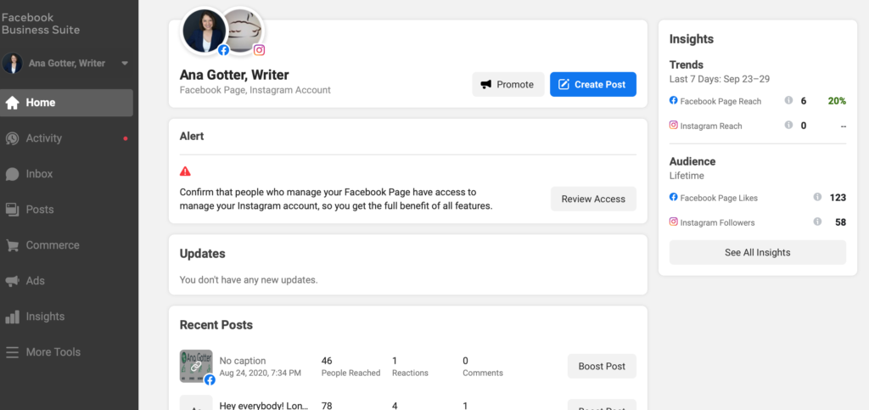

Facebook business suite

Combin Free Instragram Scheduler

Combin's goal is to provide efficient Instagram marketing solutions. It doesn't have any mobile version. It only has a desktop version. The application has to be running in the background to post on Instagram. It doesn't support any other platform and medias.

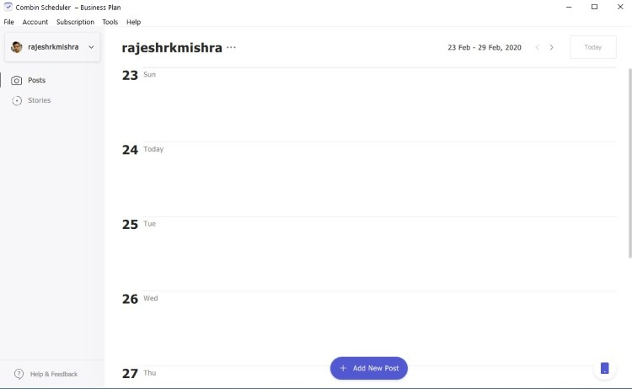

Combin-Scheduler

Buffer

Buffer is another social media management tool. It allows you to manage multiple accounts with pricing. Buffer let's us use facebook, twitter, Instagram and Linkedin to connect and schedule post. It uploads everything required to some cloud and then post when it's required to. Buffer has an analytic section as well which gives the user some insights about the posts.

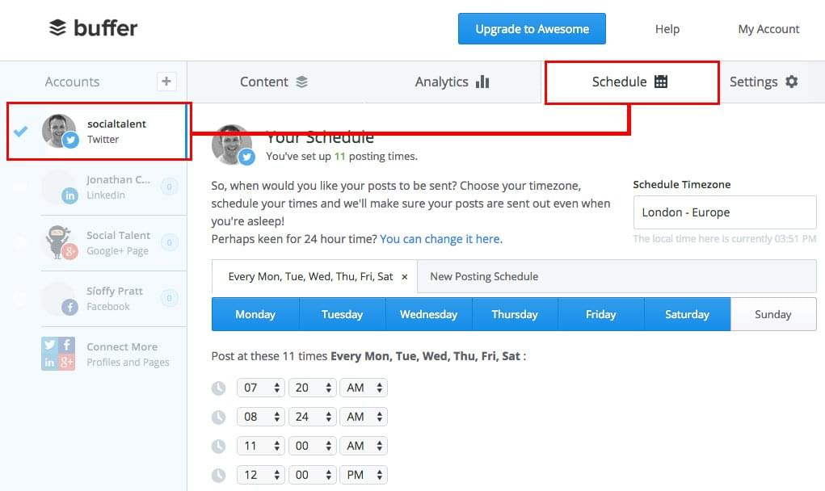

Buffer Social Media

Hootsuite

Hootsuite is another useful application for managing social media network channels. Often referred to as a social media management system or tool, it enables you to view multiple streams at once and monitor what customers are saying. You can post updates, read responses, schedule messages, view statistics, and much more. Many international brands—including Coca-Cola and Sony Music—utilize this timesaving approach to social media marketing. With Hootsuite, you can post updates, review responses, and connect with your customer base on over thirty-five popular social networks, including Twitter, Facebook (includes Profiles, Events, Groups, and Fan Pages), LinkedIn (includes Profiles, Pages, and Groups), Google+, Foursquare, WordPress blogs and several other platforms via third party apps.

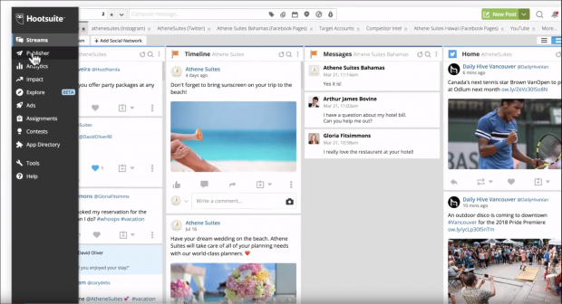

Hootsuite

SocialPilot

SocialPilot is a social media scheduling and marketing platform developed specifically for agencies and social media professionals. Used by over 40,000 agencies and social media teams, SocialPilot is designed to help users enhance the efficiency of their online marketing strategies and efforts, and save time and money. Moderately priced and appropriately integrated, SocialPilot is meant to be accessible for businesses of all scales and industries. In fact, there is a free starter package for 3 connected profiles you could use to examine the features, and confirm SocialPilot is a smart choice for your business.

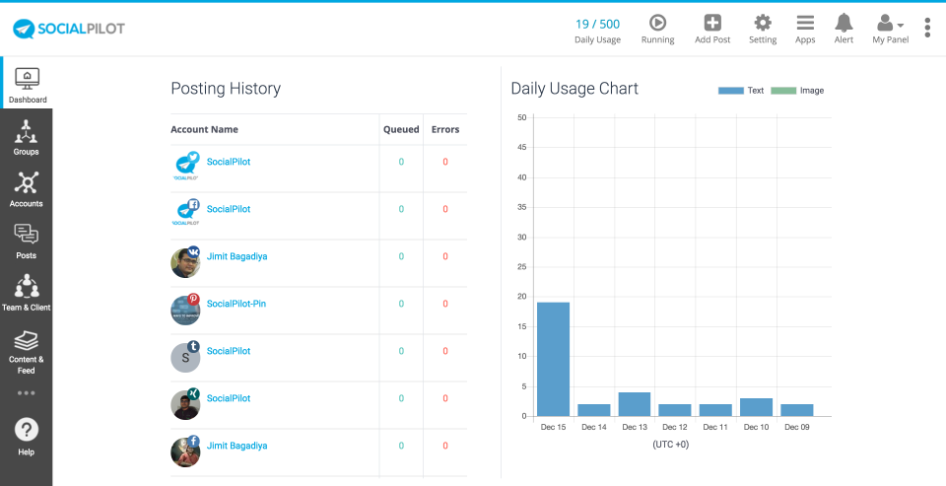

SocialPilot

Sendible

The Sendible platform brings all your social networks together into a centralised hub and is the easiest way to execute a winning social media strategy for multiple brands at scale. Positioned as a productivity tool for agencies, you can be certain that your team will save hours of time!

With powerful social media engagement, monitoring, publishing, lead generation and reporting features, Sendible gives you all the tools to delight your clients every step of the way.

Sendible's social media automation features help to simplify the process of driving interactions, growing a following and starting conversations on social media. The unified Priority Inbox is loved by brands and agencies alike, who are saving hours each day by consolidating the most important conversations from multiple sources into a single stream. With gorgeous social media reports that are designed to impress, you can deliver both meaningful and impressive-looking insights showcasing your progress on social media.

eclincher

eclincher platform is built for companies who are looking for an intuitive yet powerful solution to manage their brand reach, reputation and growth online. Popular features include: suggested content & free media assets, live inbox to interact across all channels / message types, post editing, scheduler & visual calendar, post boost, monitoring with live feeds, smart queues & auto posting, analytics & reports, team collaboration & workflows, mobile app.

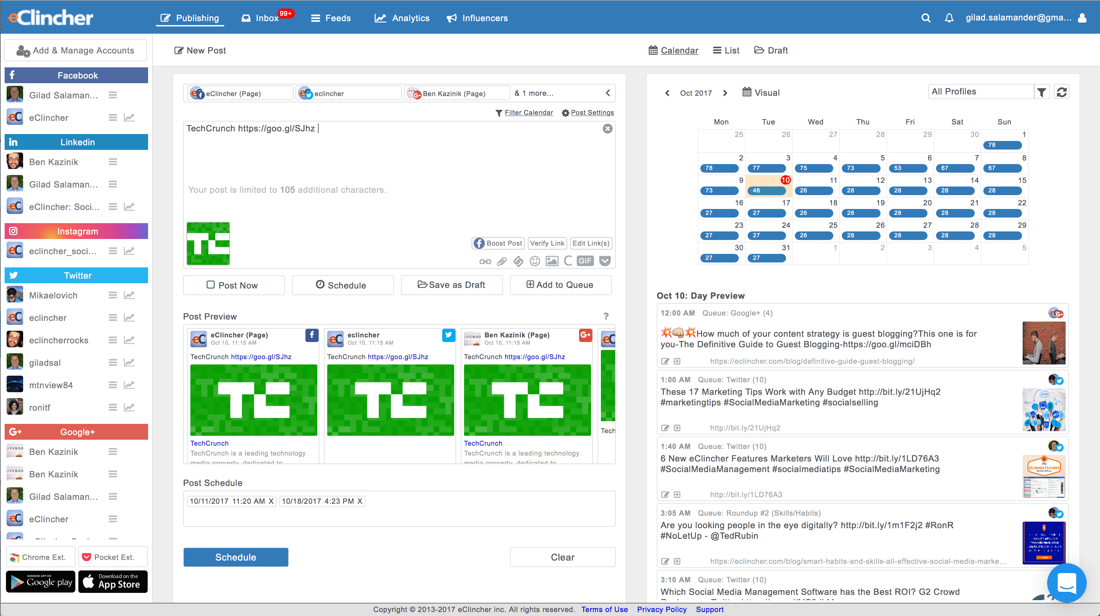

eclincher

Sprout Social

Sprout Social offers powerful social customer service solutions for leading agencies and brands including Hyatt, Ogilvy, Leo Burnett, Evernote and Microsoft. Sprout enables brands to simplify social monitoring, listening, customer service, engagement and much more. Sprout supports Facebook, Twitter, Instagram, LinkedIn and Google+ & integrates with Bitly, Google Analytics, Zendesk, Feedly & UserVoice.

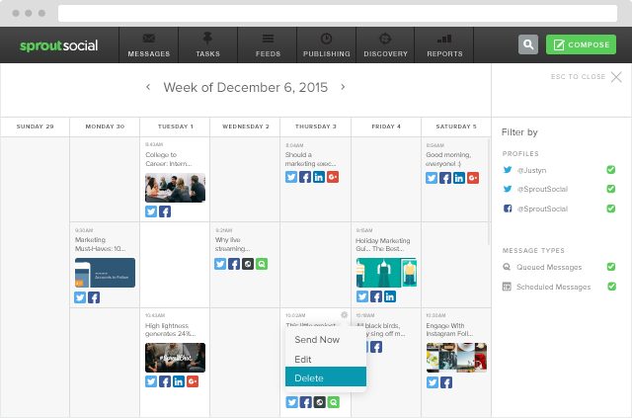

Sprout Social

|  |  |  |  |  |  |  |  |  |
| --- | --- | --- | --- | --- | --- | --- | --- | --- |
| Application | Scheduling | Analytics | Moderation | Collaboration | Content Curation | Bulk Scheduling | Cost of 5 user | Free Version |
| SociaPilot | ✔ | ✔ | ✔ | ✔ | ✔ | ✔ | 50/m | ✖ |
| Hootsuite | ✔ | ✔ | ✔ | ✔ | ✔ | ✖ | 599/m | ✔ |
| Buffer | ✔ | ✔ | ✖ | ✔ | ✖ | ✖ | 99/m | ✔ |
| Sendible | ✔ | ✔ | ✔ | ✔ | ✔ | ✔ | 199/m | ✖ |
| AgoraPulse | ✔ | ✔ | ✔ | ✔ | ✖ | ✖ | 199/m | ✖ |
| Sprout Social | ✔ | ✔ | ✔ | ✔ | ✔ | ✔ | 149/m | ✖ |
| CoSchedule | ✔ | ✔ | ✖ | ✔ | ✖ | ✖ | 400/m | ✖ |
| Zoho Social | ✔ | ✔ | ✔ | ✔ | ✖ | ✔ | 200/m | ✖ |
| eClicher | ✔ | ✔ | ✔ | ✔ | ✔ | ✔ | 219/m | ✖ |
| MavSocial | ✔ | ✔ | ✔ | ✔ | ✔ | ✔ | 199/m | ✖ |
| MeetEger | ✔ | ✔ | ✖ | ✖ | ✖ | ✔ | 49/m | ✖ |
| SmartQueue | ✔ | ✔ | ✖ | ✖ | ✔ | ✔ | 79.99/m | ✖ |

Purpose

Proposal

Architecture Pattern- Architecture pattern is given below.

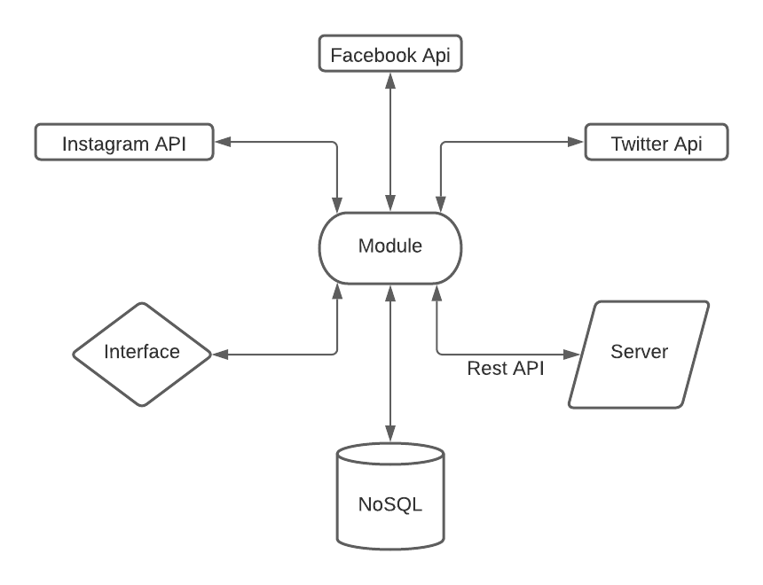

Architecture Pattern

We will be using MVVM architecture for our Application.

MVVM - MVVM architecture is a Model-View-ViewModel architecture that removes the tight coupling between each component. Most importantly, in this architecture, the children don't have the direct reference to the parent, they only have the reference by observables.

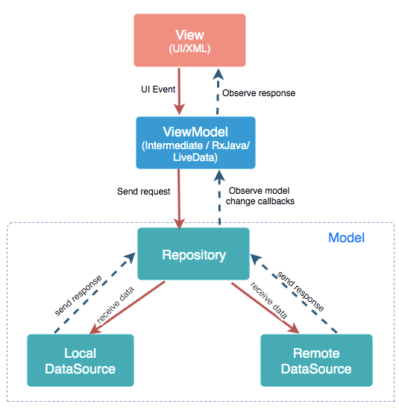

MVVM Architecture

* Model: It represents the data and the business logic of the Android Application. It consists of the business logic - local and remote data source, model classes, repository.
* View: It consists of the UI Code(Activity, Fragment), XML. It sends the user action to the ViewModel but does not get the response back directly. To get the response, it has to subscribe to the observables which ViewModel exposes to it.
* ViewModel: It is a bridge between the View and Model(business logic). It does not have any clue which View has to use it as it does not have a direct reference to the View. So basically, the ViewModel should not be aware of the view who is interacting with. It interacts with the Model and exposes the observable that can be observed by the View.

For our Database we will be using NOSQL database. Firebase is a Backend-as-a-Service. It provides developers with a variety of tools and services to help them develop quality apps, grow their user base, and earn profit. It is built on Google’s infrastructure.

* Authentication: It supports authentication using passwords, phone numbers, Google, Facebook, Twitter, and more. The Firebase Authentication (SDK) can be used to manually integrate one or more sign-in methods into an app.
* Realtime database: Data is synced across all clients in realtime and remains available even when an app goes offline.
* Hosting: Firebase Hosting provides fast hosting for a web app; content is cached into content delivery networks worldwide.
* Test lab: The application is tested on virtual and physical devices located in Google’s data centers.
* Notifications: Notifications can be sent with firebase with no additional coding.

Conclusion